Mini Project Report On
“ Smart Parking Management System ”

Submitted by:
Parth Mohurle - RBT25ET072(68)
Saurav Bhonde - RBT25ET027(67)

Under the guidance of
Prof. Rutuja S. Bachhav
Course: DBMS

Academic Year: 2026–27 (Semester III)

Table of Contents

1. Abstract 5
2. Introduction 6
3. Literature Survey / Existing System 8
4. Proposed System 9
5. Methodology / Implementation 15
6. Results and Discussion 20
7. Conclusion and Future Scope 23
8. References 24
9. Appendix 25

Course Outcomes:
CO1: Design a database schema and 2 –tier application for a given problem statement.
CO2: Design SQL DDL/DML quries to create, secure, populate, maintain, and query a database using integrity constraint, stored function/procedure, cursor, trigger using PL/SQL block.
CO2: Design NO SQL query using mongoDB platform.

PO Mapped
PO1: Engineering Knowledge: Apply knowledge of mathematics, natural science, computing,
engineering fundamentals and an engineering specialization as specified in WK1 to WK4 respectively to develop to the solution of complex engineering problems
PO2: Problem Analysis: Identify, formulate, review research literature and analyze complex engineering problems reaching substantiated conclusions with consideration for sustainable development.
PO3: Design/Development of Solutions: Design creative solutions for complex engineering problems and design/develop systems/components/processes to meet identified needs with consideration for the public health and safety, whole-life cost, net zero carbon, culture, society and environment as required.
PO4: Conduct Investigations of Complex Problems: Conduct investigations of complex engineering problems using research-based knowledge including design of experiments, modeling, analysis & interpretation of data to provide valid conclusions.
PO5: Engineering Tool Usage: Create, select and apply appropriate techniques, resources and modern engineering & IT tools, including prediction and modeling recognizing their limitations to solve complex engineering problems.
PO8: Individual and Collaborative Team work: Function effectively as an individual, and as a member or leader in diverse/multi-disciplinary teams.
PO9: Communication: Communicate effectively and inclusively within the engineering community and society at large, such as being able to comprehend and write effective reports and design documentation, make effective presentations considering cultural, language, and learning differences
PO10: Project Management and Finance: Apply knowledge and understanding of engineering management principles and economic decision-making and apply these to one’s own work, as a member and leader in a team, and to manage projects and in multidisciplinary environments.
PO11: Life-Long Learning: Recognize the need for, and have the preparation and ability for i) independent and life-long learning ii) adaptability to new and emerging technologies and iii) critical thinking in the broadest context of technological change.

PSO Mapped
PSO 1: Integrated Technical Proficiency: Ability to analyze, designs, and implement comprehensive software and business systems using modern tools and techniques, ensuring intelligent, efficient, and sustainable solutions.
PSO 2: Data-Driven Decision Making: Ability to apply mathematical and data analytics methods including algorithms, statisticalmodels, and data structures to solve complex computational and business problems and support innovation.
PSO 3: Interdisciplinary Collaboration & Professionalism: Ability to effectively collaborate in multidisciplinary teams, integrating technical and business perspectives, and to communicate and manage projects with professional ethics and societal responsibility.
SDG Goals Mapped
SDG 4: Quality Education: Develops students’ practical skills in database design, SQL, PL/SQL, NoSQL, and modern database technologies.
SDG 8: Decent Work and Economic Growth: Enhances students’ technical and problem-solving skills required for employment and professional development in the IT industry.
SDG 9: Industry, Innovation and Infrastructure: Promotes the development of technology-based database solutions using SQL, PL/SQL, and MongoDB.
SDG 12: Responsible Consumption and Production: Encourages efficient data management, storage, and utilization of computing resources.
- Abstract
The Smart Parking Management System is a database-driven desktop application developed to manage parking lots, parking slots, vehicles, owners, reservations and parking fees. It is implemented with a Python Tkinter front end and a MySQL back end, forming a two-tier application.
The project uses a normalized (3NF) relational database of nine tables: users, vehicle_owners, vehicles, parking_lots, parking_slots, parking_records, pricing, payments and reservations. Primary keys, foreign keys and UNIQUE, NOT NULL and CHECK constraints keep the data consistent. A trigger updates the slot status automatically, a stored procedure calculates the fee, a view reports live availability for every lot, and an index on plate_number speeds up vehicle search. All queries are parameterized, and entry, exit and payment run as transactions.
The application allocates the first free slot that matches the vehicle type, issues an entry ticket, charges hours (rounded up) × hourly rate on exit, records payment by Cash, UPI or Card, and frees the slot. It also provides a live dashboard, reservations, history reports with filters, daily revenue analytics and CSV export for admin and attendant users, which reduces manual record keeping and human errors.
Keywords: DBMS, MySQL, Python, Tkinter, Smart Parking, Relational Database, Normalization, Trigger, Stored Procedure, View, SQL JOIN
- Introduction
Background / Motivation
A parking facility handles a large amount of information every day: the vehicles that enter and leave, the slots that are free or occupied, entry and exit times, reservations and the fees collected. In a traditional system this information is kept on paper tickets, registers or separate spreadsheets. As the number of lots, slots and vehicles grows, finding a free slot, tracing a vehicle and calculating the correct fee become time-consuming and error-prone.
A Database Management System stores this information in an organized and structured manner. The Smart Parking Management System developed in this project uses MySQL as a relational database and a Python Tkinter interface, so that a non-technical attendant can operate the database without writing any SQL.
Problem Definition
Manual parking management causes wrong slot status, duplicate or missing entries, fee calculation mistakes and slow searching for a parked vehicle. There is no live view of free slots and no quick daily revenue report. A database-driven system is therefore needed to allocate slots, bill vehicles and report revenue accurately.
The system contains nine tables. Owners and vehicles are stored in vehicle_owners and vehicles; lots and slots in parking_lots and parking_slots; every visit in parking_records, with its fee in payments; advance bookings in reservations; hourly rates in pricing; and login accounts in users.
The project demonstrates important DBMS concepts such as database and table creation, data types and constraints, primary keys, foreign keys, normalization, relationships, triggers, stored procedures, views, indexes, transactions, SQL JOIN operations and aggregate functions.
Objectives
The main objectives of the project are:
- To store vehicle, owner, parking lot and slot information in a normalized (3NF) schema.
- To allocate the first available slot that matches the vehicle type automatically.
- To update the slot status automatically with a MySQL trigger on entry and exit.
- To calculate the parking fee (hours rounded up × hourly rate) and record the payment.
- To support slot reservations and role-based access for admin and attendant users.
- To show a live dashboard, searchable parking history and daily revenue reports with CSV export.
- To demonstrate practical DBMS and SQL concepts using MySQL and Python.
- Literature Survey / Existing System
Review of related tools or existing systems
Traditional parking lots commonly use paper tickets, manual registers or basic spreadsheet files to record vehicles and collect fees. These methods suit a very small lot but become difficult to manage when the number of slots, vehicles and daily transactions increases.
In a manual system, finding out whether a slot is free needs a physical check, and tracing a vehicle requires searching through many pages. The fee is calculated by hand from the entry and exit times, so a single wrong entry changes the revenue recorded for the day.
Gaps identified
The limitations of the existing system are:
- Time-consuming: Searching for a vehicle or a free slot and updating records takes more time.
- Slot allocation errors: Slot status is updated by hand, so a slot may be allotted twice or shown wrongly.
- Fee calculation errors: Time and rate are calculated manually, which leads to incorrect amounts.
- No vehicle history: Past visits of a vehicle or owner cannot be retrieved quickly.
- No reservations: Advance booking of slots is not supported or is tracked in notebooks.
- Limited reporting: Occupancy and daily revenue cannot be generated without counting records by hand.
A relational database system solves many of these problems by storing data in structured tables, enforcing constraints and establishing relationships between related records.
- Proposed System
System Overview
The proposed Smart Parking Management System uses a relational database to store and manage parking information in a structured manner. MySQL is used to create the database, tables, relationships, trigger, stored procedure, view and queries, while a Python Tkinter application provides the user interface and connects to MySQL through the mysql-connector-python library.
After login (admin or attendant), the main window shows seven tabs: Dashboard, Vehicle Entry, Vehicle Exit, Slot Management, Reservations, Records & Reports and Admin Panel.
Features / Scope
- Login and roles: Admin and attendant accounts; passwords are stored as SHA-256 hashes; admin-only screens.
- Dashboard: Total, available, occupied and reserved slots, active vehicles, today's revenue and lot-wise utilization.
- Vehicle Entry: Looks up an existing vehicle, auto-allocates the closest matching slot and prints an entry ticket.
- Vehicle Exit: Searches by plate number, calculates duration and fee, records the payment and frees the slot.
- Slot Management: Colour-coded slot status (available, occupied, reserved) with add, edit and delete for admin.
- Reservations: Book and cancel slots for a future time period.
- Records & Reports: Parking history with plate, status and date filters, daily revenue analytics and CSV export.
- Admin Panel: Manage pricing (rate per hour for each vehicle type) and users.
System Architecture Diagram
The system follows a two-tier architecture. The client tier is the Tkinter application; the database tier is the MySQL server. The two tiers communicate through mysql-connector-python using parameterized SQL statements.
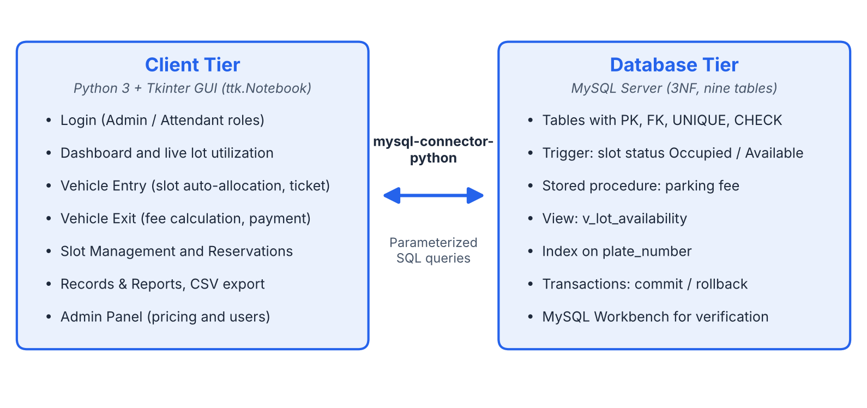
Fig 4.1: Two-tier architecture of the Smart Parking Management System
Database Design
The database consists of nine tables, normalized up to Third Normal Form (3NF). Each table has a primary key, and related tables are linked through foreign keys so that no data is repeated unnecessarily. The data dictionary of every table is given below.
1. vehicle_owners Table
Stores the owner of each vehicle.
Attribute | Data Type | Constraint / Description
owner_id | INT | Primary Key, AUTO_INCREMENT
name | VARCHAR(100) | NOT NULL
phone | VARCHAR(20) | NOT NULL
email | VARCHAR(100) | Optional
created_at | TIMESTAMP | Default CURRENT_TIMESTAMP

2. vehicles Table
Stores each vehicle and links it to its owner.
Attribute | Data Type | Constraint / Description
vehicle_id | INT | Primary Key, AUTO_INCREMENT
plate_number | VARCHAR(20) | UNIQUE, NOT NULL (indexed)
vehicle_type | ENUM | 'Bike', 'Car', 'Truck'; NOT NULL
owner_id | INT | Foreign Key → vehicle_owners(owner_id)
created_at | TIMESTAMP | Default CURRENT_TIMESTAMP

3. parking_lots Table
Stores the parking lots (buildings or decks).
Attribute | Data Type | Constraint / Description
lot_id | INT | Primary Key, AUTO_INCREMENT
lot_name | VARCHAR(100) | NOT NULL
location | VARCHAR(150) | Where the lot is situated
total_capacity | INT | NOT NULL, CHECK (> 0)

4. parking_slots Table
Stores every slot of every lot with its live status.
Attribute | Data Type | Constraint / Description
slot_id | INT | Primary Key, AUTO_INCREMENT
lot_id | INT | Foreign Key → parking_lots(lot_id)
slot_number | VARCHAR(10) | e.g. A-C01; unique within a lot
slot_type | ENUM | 'Bike', 'Car', 'Truck'
status | ENUM | 'Available', 'Occupied', 'Reserved', 'Maintenance'

5. parking_records Table
Records every visit of a vehicle, from entry to exit.
Attribute | Data Type | Constraint / Description
record_id | INT | Primary Key, AUTO_INCREMENT
vehicle_id | INT | Foreign Key → vehicles(vehicle_id)
slot_id | INT | Foreign Key → parking_slots(slot_id)
entry_time | DATETIME | NOT NULL
exit_time | DATETIME | NULL while the vehicle is parked
status | ENUM | 'Active', 'Completed'

6. pricing Table
Stores the hourly rate for each vehicle type.
Attribute | Data Type | Constraint / Description
vehicle_type | ENUM | Primary Key ('Bike', 'Car', 'Truck')
rate_per_hour | DECIMAL(8,2) | NOT NULL, CHECK (> 0)

7. payments Table
Stores the payment made when a vehicle exits.
Attribute | Data Type | Constraint / Description
payment_id | INT | Primary Key, AUTO_INCREMENT
record_id | INT | Foreign Key → parking_records(record_id)
amount | DECIMAL(10,2) | NOT NULL
payment_mode | ENUM | 'Cash', 'UPI', 'Card'
payment_time | DATETIME | Default CURRENT_TIMESTAMP

8. reservations Table
Stores advance bookings of slots.
Attribute | Data Type | Constraint / Description
reservation_id | INT | Primary Key, AUTO_INCREMENT
vehicle_id | INT | Foreign Key → vehicles(vehicle_id)
slot_id | INT | Foreign Key → parking_slots(slot_id)
reserve_from | DATETIME | NOT NULL
reserve_to | DATETIME | NOT NULL
status | ENUM | 'Active', 'Cancelled', 'Completed'

9. users Table
Stores the login accounts of the system.
Attribute | Data Type | Constraint / Description
user_id | INT | Primary Key, AUTO_INCREMENT
username | VARCHAR(50) | UNIQUE, NOT NULL
password_hash | VARCHAR(64) | SHA-256 hash, NOT NULL
role | ENUM | 'Admin', 'Attendant'

Entity-Relationship (ER) Diagram
The ER diagram shows the nine tables with their primary keys and foreign keys. One owner can have many vehicles; one vehicle can have many parking records and reservations; one lot has many slots; one slot can appear in many records and reservations; and one parking record has its payment. The tables pricing and users are standalone.
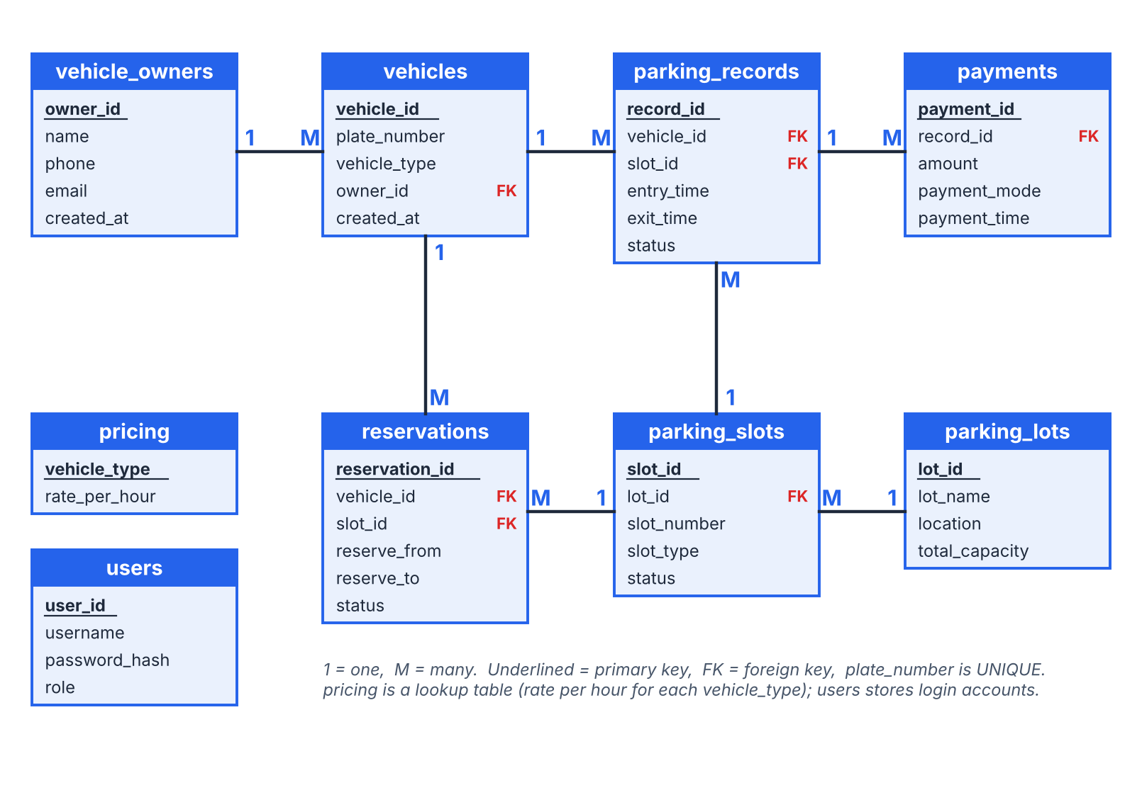
Fig 4.2: ER diagram of the Smart Parking Management System
Advantages of the Proposed System
- Organized storage of vehicle, owner, lot, slot and payment information.
- Slot status is updated automatically by a trigger, so it is always correct.
- The first free slot of the matching type is allocated automatically.
- The fee is calculated by a stored procedure, which avoids human errors.
- Live availability of every lot is available through a database view.
- SQL queries, filters and the plate-number index allow quick data retrieval and reports.
- Methodology / Implementation
The project was developed using a relational database approach with a two-tier architecture. The first tier is the client application written in Python with the Tkinter library. The second tier is the MySQL database server. The application sends SQL statements to MySQL through the mysql-connector-python library, and MySQL Workbench was used to manage the database and to verify the stored data.
Tools and Technologies Used
- Python 3 with the Tkinter library (ttk.Notebook, ttk.Treeview) for the graphical user interface
- mysql-connector-python (connection between Python and MySQL)
- MySQL Server and MySQL Workbench (database, queries and verification)
- hashlib (SHA-256) for password hashing, and the csv module for report export
- Visual Studio Code (code editor)
Modules Description
1. Database Creation and Tables
A MySQL database was created for the project and the nine tables were created with appropriate data types, NOT NULL, UNIQUE and CHECK constraints and AUTO_INCREMENT primary keys. Foreign keys connect the related tables: vehicles.owner_id references vehicle_owners.owner_id; parking_slots.lot_id references parking_lots.lot_id; parking_records.vehicle_id and parking_records.slot_id reference vehicles and parking_slots; payments.record_id references parking_records.record_id; and reservations.vehicle_id and reservations.slot_id reference vehicles and parking_slots. A vehicle, slot or lot that is already used in a record cannot be deleted, because the foreign key constraint rejects the deletion and the application shows an error message.
2. Data Insertion and Security
Sample lots (three lots with ten slots each), slots, owners, vehicles, pricing and records were inserted. New data is added through the forms of the application. All SQL statements use parameterized queries with %s placeholders, so the values entered by the user are never joined directly into the SQL text, which protects the database against SQL injection. Passwords are stored only as SHA-256 hashes.
3. Database Objects (Trigger, Stored Procedure, View and Index)
- Trigger: When a parking record is inserted, the trigger sets the slot status to 'Occupied'; when the record is completed on exit, the slot is set back to 'Available'.
- Stored procedure: Calculates the parking fee as hours (rounded up) × the hourly rate of the vehicle type from the pricing table.
- View v_lot_availability: Gives the capacity, available, occupied, reserved and maintenance slots and the occupancy percentage of every lot; the dashboard reads it.
- Index: An index on vehicles.plate_number makes the search by plate number fast.
4. Vehicle Entry and Slot Auto-Allocation
In the Vehicle Entry tab the attendant enters the licence plate, vehicle type, owner name, phone number and optional email, and may choose a particular lot. The Lookup Existing button fills the details of a vehicle that has visited before. When Auto-Allocate Slot is pressed, the application checks that the plate has no active record, finds the first available slot of the matching type, inserts a new row in parking_records inside a transaction (the trigger marks the slot as Occupied) and shows an entry ticket. If no slot is free, or the vehicle is already parked, a clear error message is shown.
5. Vehicle Exit and Billing
In the Vehicle Exit tab the attendant searches the active record by plate number. The application calculates the parked duration, calls the stored procedure for the fee, records the payment mode (Cash, UPI or Card) in the payments table, marks the record as Completed and frees the slot. All these steps are executed as one transaction, so either everything is saved or everything is rolled back.
6. Slot Management, Reservations and Admin
Slot Management lists all slots with colour coding (green for available, red for occupied, orange for reserved), and the admin can add, edit or delete slots. The Reservations tab books and cancels slots for a time period. The Admin Panel manages the hourly pricing and the users. Admin-only screens are hidden from attendants.
7. Records and Reports
The Records & Reports tab shows the parking history with filters for plate number, status and date range, a Daily Revenue Analytics tab, and an Export to CSV button.
Algorithms / Frameworks (if applicable)
- Slot allocation: select the first slot with status 'Available' and the same type as the vehicle (optionally within the chosen lot), ordered by lot and slot number.
- Fee calculation: fee = CEIL(parked minutes / 60) × rate_per_hour. For example, a car parked for 2 hours 15 minutes is charged for 3 hours; with a rate of ₹50 per hour the fee is ₹150.
- Password hashing: the SHA-256 hash of the password is compared with the stored password_hash at login.
- Transactions: entry, exit and payment use commit on success and rollback on any error.
Screenshots or Outputs
The following screenshots show the working of the Smart Parking Management System.
[Paste screenshot here: Login screen (admin / attendant)]
Fig 5.1: Login screen
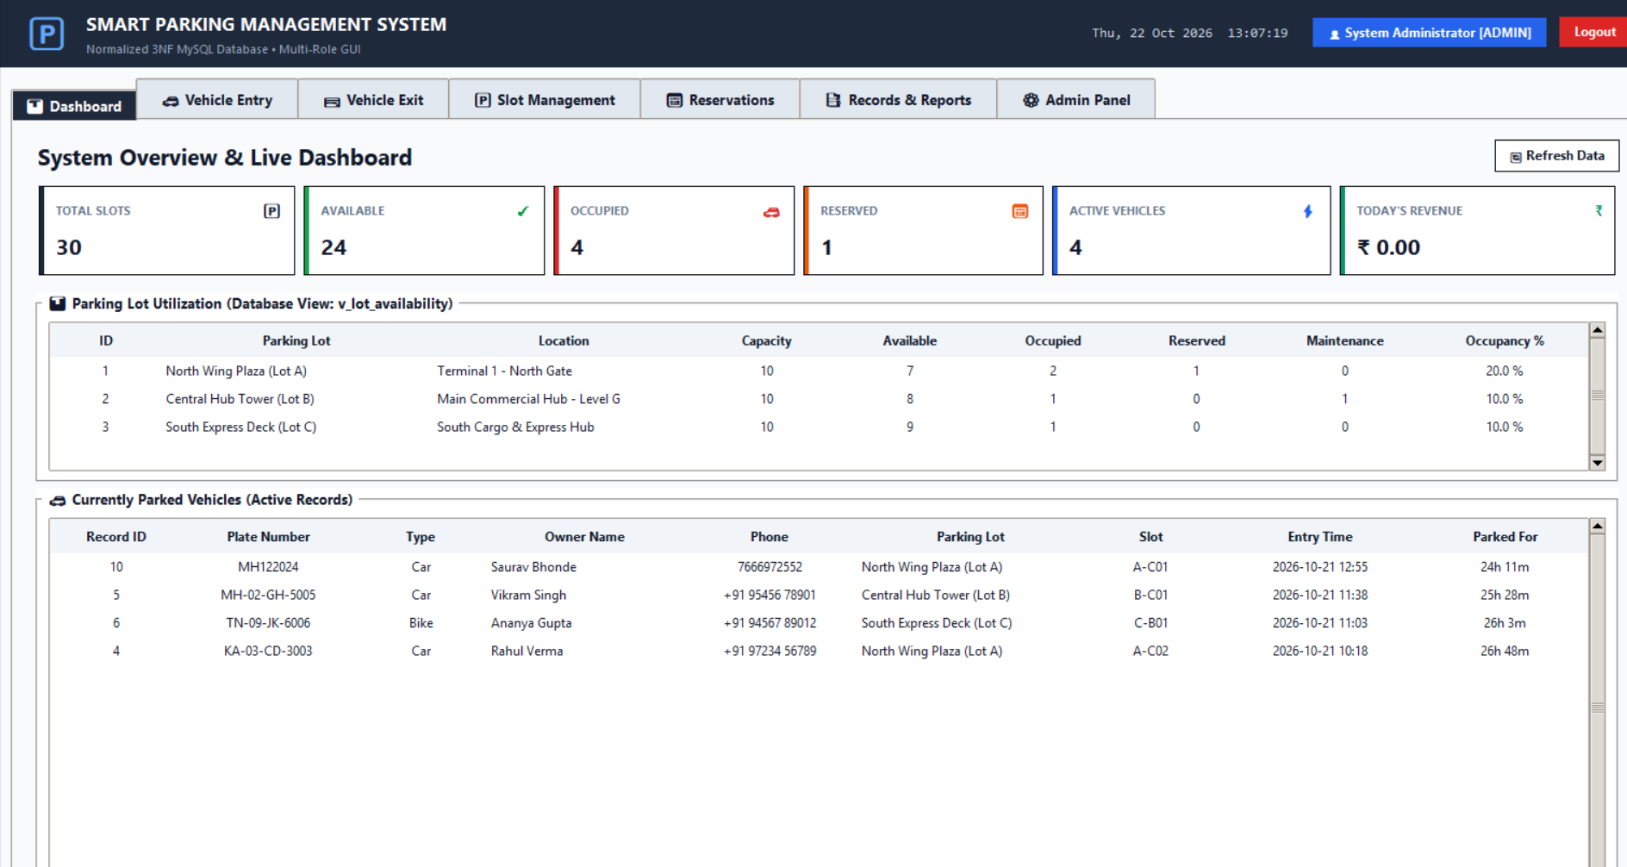
Fig 5.2: Dashboard with live slot counts, lot utilization and active vehicles
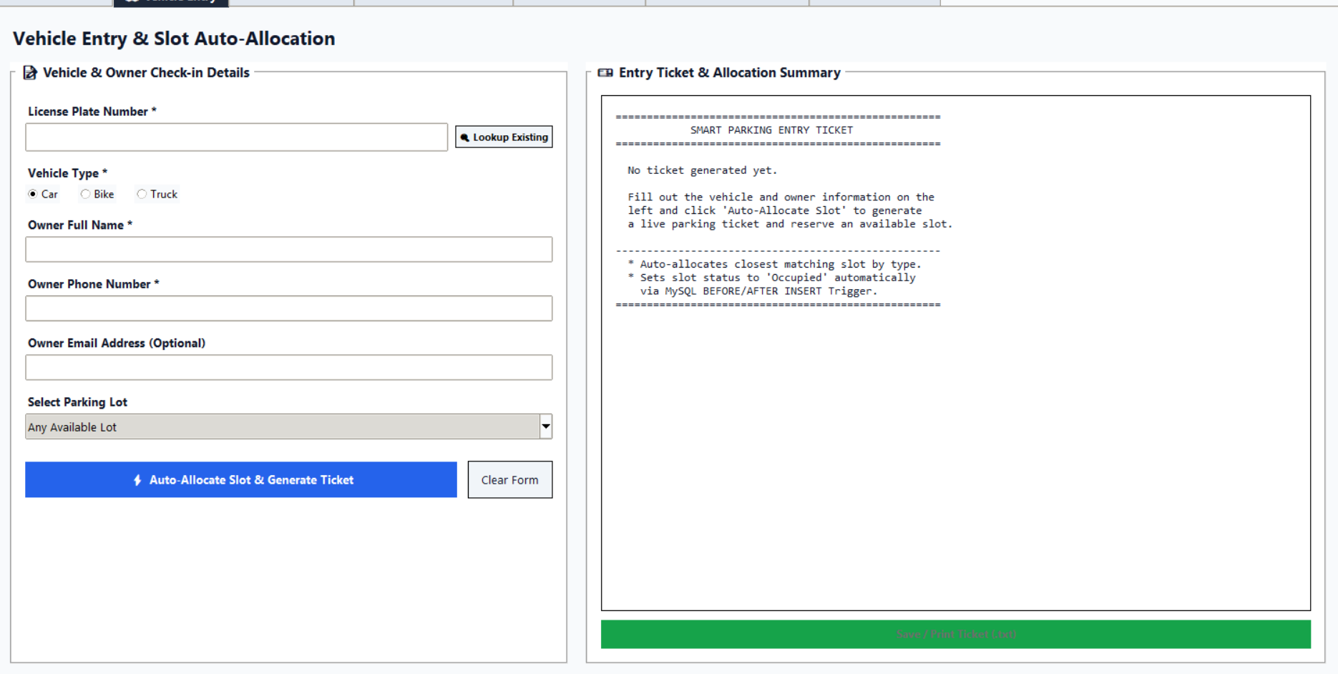
Fig 5.3: Vehicle Entry and slot auto-allocation
[Paste screenshot here: Vehicle Exit and payment screen]
Fig 5.4: Vehicle Exit, fee calculation and payment
[Paste screenshot here: Slot Management screen with colour-coded slots]
Fig 5.5: Slot Management (green = available, red = occupied, orange = reserved)
[Paste screenshot here: Reservations screen]
Fig 5.6: Reservations
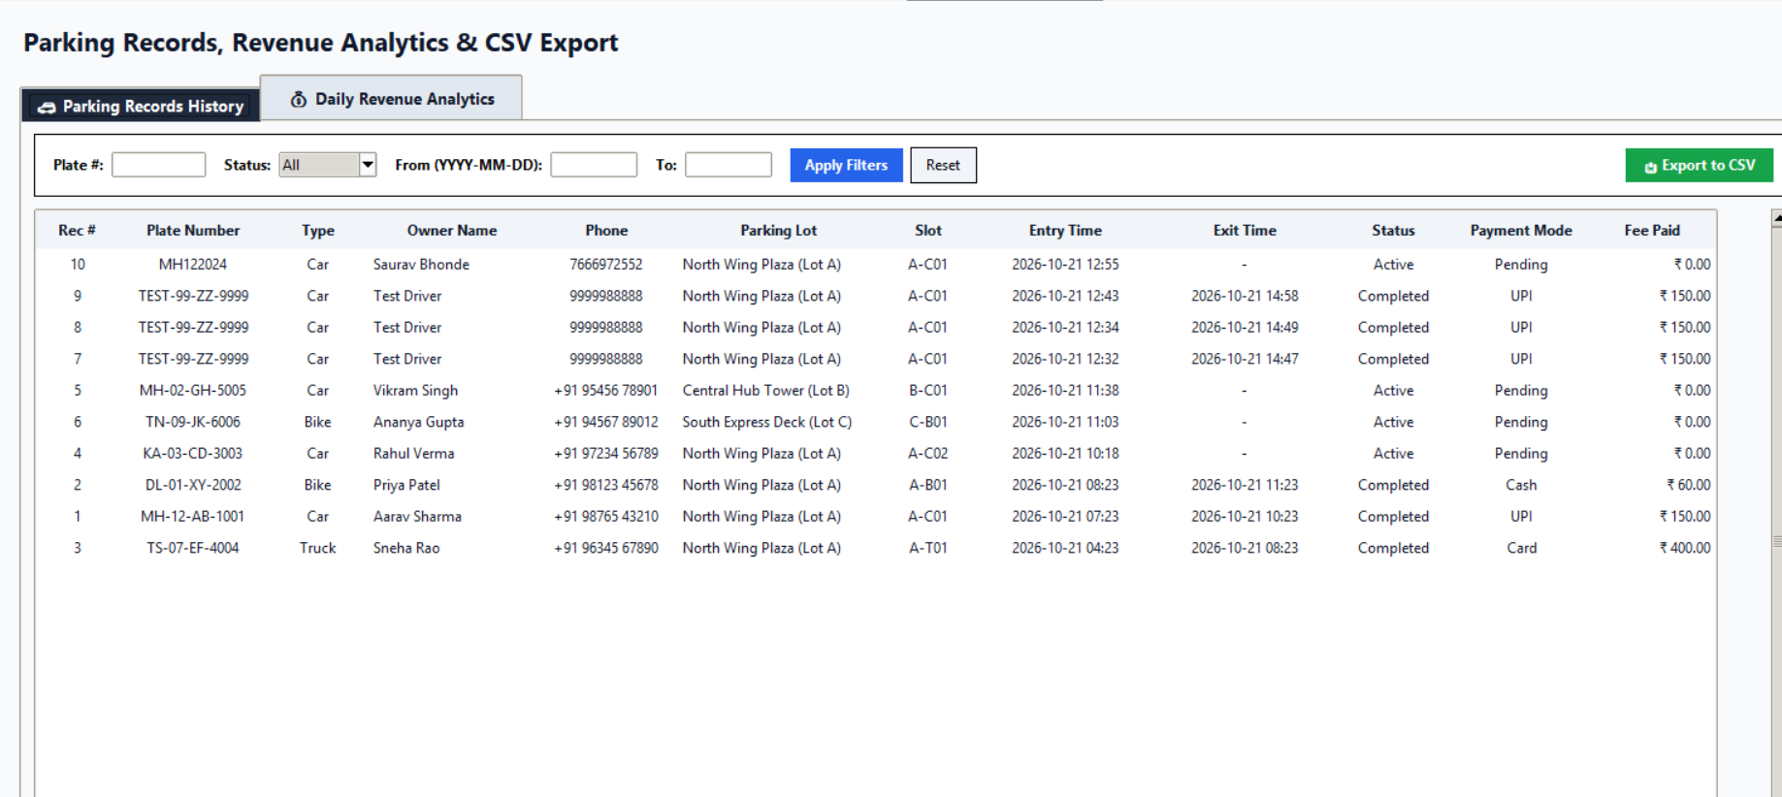
Fig 5.7: Records & Reports with filters and CSV export
[Paste screenshot here: Admin Panel (pricing and users)]
Fig 5.8: Admin Panel
- Results and Discussion
Outputs achieved
The Smart Parking Management System was successfully implemented using Python and MySQL. The database was created with nine related tables. Sample vehicles were entered through the application, slots were allocated, fees were calculated and payments were recorded, and SQL queries were executed to verify the stored data.
1. Database Tables
The SHOW TABLES command was used to verify the successful creation of the database tables.
SHOW TABLES;
The result confirms the presence of the nine tables: parking_lots, parking_records, parking_slots, payments, pricing, reservations, users, vehicle_owners and vehicles.
[Paste screenshot here: Output of SHOW TABLES in MySQL Workbench]
Fig 6.1: Output of SHOW TABLES
2. Lot Availability using the View
The view v_lot_availability combines lots and slots and gives the live availability of every lot. The following query reads it:
SELECT * FROM v_lot_availability;
The result shows, for each of the three lots, the capacity (10 slots each), and the number of available, occupied, reserved and maintenance slots together with the occupancy percentage. The same data is shown on the dashboard.
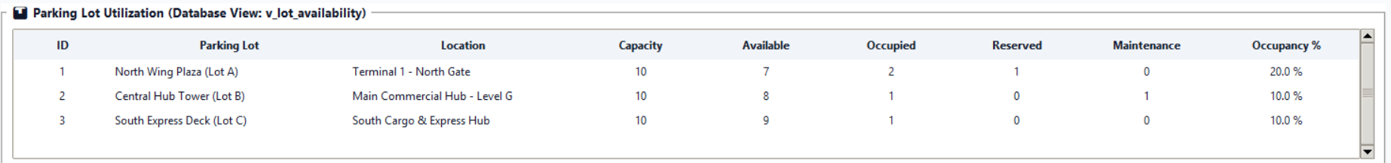
Fig 6.2: Parking lot utilization returned by v_lot_availability
3. Currently Parked Vehicles using JOIN
The parking_records table stores only the IDs of the vehicle and the slot. A JOIN query was used to display the plate number, owner and slot name together with each active record:
SELECT r.record_id, v.plate_number, v.vehicle_type,
o.name AS owner, o.phone, l.lot_name,
s.slot_number, r.entry_time
FROM parking_records r
JOIN vehicles v ON v.vehicle_id = r.vehicle_id
JOIN vehicle_owners o ON o.owner_id = v.owner_id
JOIN parking_slots s ON s.slot_id = r.slot_id
JOIN parking_lots l ON l.lot_id = s.lot_id
WHERE r.status = 'Active'
ORDER BY r.entry_time DESC;
The query combines five tables through their primary and foreign keys and lists the most recent entry first. This is the query that fills the Currently Parked Vehicles table of the dashboard.
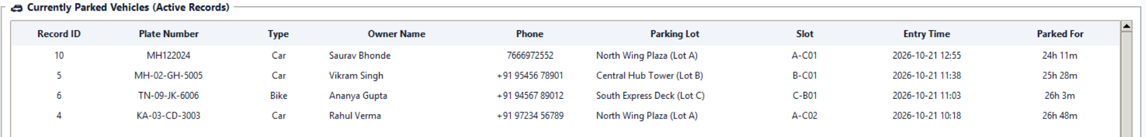
Fig 6.3: Currently parked vehicles (active records)
4. Daily Revenue using GROUP BY
An aggregate query with GROUP BY was used to calculate the revenue collected on each day and the number of payments:
SELECT DATE(payment_time) AS day,
COUNT(*) AS payments,
SUM(amount) AS revenue
FROM payments
GROUP BY DATE(payment_time)
ORDER BY day DESC;
[Paste screenshot here: Daily Revenue Analytics tab or the query output in MySQL Workbench]
Fig 6.4: Daily revenue report
Performance / Accuracy (if measurable)
- The database holds 30 slots in 3 lots (10 slots each); the dashboard counted 24 available, 4 occupied and 1 reserved slot, and one slot under maintenance.
- The parking history contains 10 records, of which 4 are active and 6 are completed with payments in Cash, UPI and Card.
- Fees were calculated correctly from the hourly rate: for example ₹60 for a bike, ₹150 for a car and ₹400 for a truck for the sample stays.
- The UNIQUE constraint and the index on plate_number prevent duplicate vehicles and give fast search by plate number.
- Invalid operations such as entering a vehicle that is already parked or entering when no slot is free are refused with an error message.
Comparison with existing methods
Aspect | Existing (manual) system | Smart Parking Management System
Slot allocation | Chosen by sight; may be allotted twice | First matching free slot allocated automatically
Vehicle search | Page-by-page in registers | Instant search by plate number (index)
Fee calculation | Manual; human errors | Stored procedure: hours × hourly rate
Slot status | Updated by hand | Updated by a trigger
Reservations | Not supported | Book and cancel from the GUI
Reporting | Counted by hand | Dashboard, filters, revenue report, CSV export

Discussion
The results confirm that the database and its tables were created successfully and that the application stores, updates and retrieves data correctly. The entry and exit modules allocate and free slots automatically, calculate the fee and refuse invalid transactions.
The view, JOIN and GROUP BY queries show how SQL can combine data from several related tables to produce meaningful information such as live availability, currently parked vehicles and daily revenue. These results show that the Smart Parking Management System can organize parking data and provide efficient retrieval of the required information.
- Conclusion and Future Scope
Summary of achievements
The Smart Parking Management System successfully demonstrates the practical application of Database Management System concepts using MySQL and Python. The system provides a structured method for storing and managing information about vehicles, owners, lots, slots, reservations and payments, and it connects a simple graphical interface with a relational database in a two-tier architecture.
The project demonstrates the use of normalized relational tables, primary keys, foreign keys, a trigger, a stored procedure, a view, an index, transactions, SQL JOIN operations, aggregate functions, role-based login and input validation. Compared with manual record keeping, the database approach provides better organization, automatic slot allocation and billing, and faster access to information.
Limitations and potential improvements
The system runs as a desktop application on a single database server and does not yet accept online payments or recognize number plates automatically. It can be further enhanced by adding:
- Automatic number plate recognition with a camera at the gate.
- Online reservation and UPI QR payment.
- SMS or email alerts for reservations and dues.
- Sensor-based (IoT) detection of slot occupancy.
- Monthly passes and dynamic pricing for peak hours.
- A web-based or mobile application interface.
- References
(Books, Research Papers, Websites, Tutorials, etc.)
- MySQL Documentation, Oracle Corporation.
- MySQL Workbench Documentation, Oracle Corporation.
- MySQL Connector/Python Developer Guide, Oracle Corporation.
- Python Documentation: tkinter — Python interface to Tcl/Tk, Python Software Foundation.
- Python Documentation: hashlib — Secure hashes and message digests, Python Software Foundation.
- R. Elmasri and S. B. Navathe, Fundamentals of Database Systems, Pearson.
- W3Schools, SQL Tutorial.
- GeeksforGeeks, DBMS and SQL Concepts.
- Database Management System course notes and classroom materials.
- Appendix
Source code snippets
Representative SQL used to create the main tables (simplified):
CREATE TABLE vehicle_owners (
owner_id INT AUTO_INCREMENT PRIMARY KEY,
name VARCHAR(100) NOT NULL,
phone VARCHAR(20) NOT NULL,
email VARCHAR(100),
created_at TIMESTAMP DEFAULT CURRENT_TIMESTAMP
);

CREATE TABLE vehicles (
vehicle_id INT AUTO_INCREMENT PRIMARY KEY,
plate_number VARCHAR(20) NOT NULL UNIQUE,
vehicle_type ENUM('Bike','Car','Truck') NOT NULL,
owner_id INT NOT NULL,
created_at TIMESTAMP DEFAULT CURRENT_TIMESTAMP,
FOREIGN KEY (owner_id) REFERENCES vehicle_owners(owner_id)
);

CREATE TABLE parking_records (
record_id INT AUTO_INCREMENT PRIMARY KEY,
vehicle_id INT NOT NULL,
slot_id INT NOT NULL,
entry_time DATETIME NOT NULL,
exit_time DATETIME NULL,
status ENUM('Active','Completed') DEFAULT 'Active',
FOREIGN KEY (vehicle_id) REFERENCES vehicles(vehicle_id),
FOREIGN KEY (slot_id) REFERENCES parking_slots(slot_id)
);
Additional screenshots
The records of the vehicles and vehicle_owners tables as seen in MySQL Workbench:
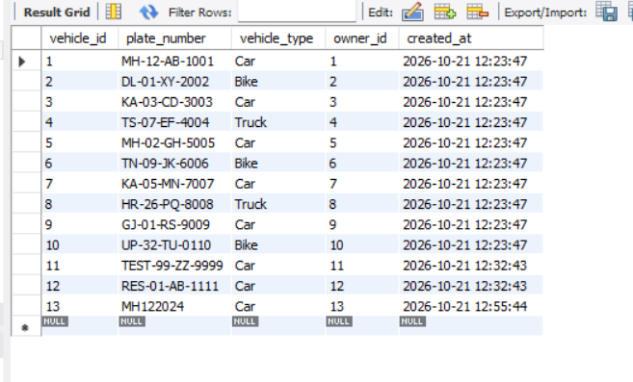
Fig 9.1: vehicles table in MySQL Workbench
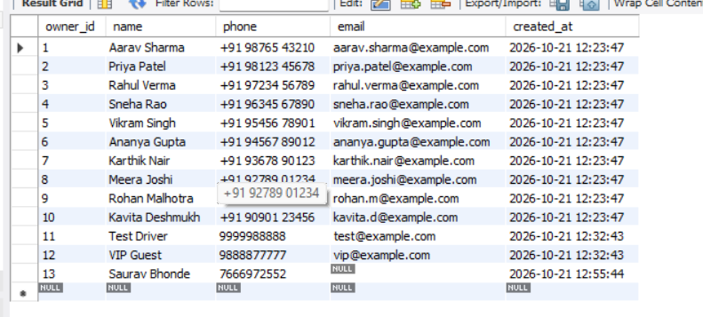
Fig 9.2: vehicle_owners table in MySQL Workbench

